NAME: G. Yashmita REG NO: 192511032
(Jira)
EXPERIMENT 1:
Create a Kanban Board to Visualize the Tasks.
1) Create Columns for To Do, In-Progress and Done.
2)Add Atleast 5 Sample Tasks
3) Move the Tasks across the Columns to Simulate the Workflow.

Aim

To create a Kanban Board in Jira Software, add sample tasks, and move them through different workflow stages to simulate software development.

Software Requirements
- Software: Jira Cloud (Web Application)
- Web Browser: Google Chrome or Microsoft Edge
- Internet Connection: Required

Theory

Jira is a project management tool used to track software development tasks. A Kanban Board displays work in different stages such as Backlog, Selected for Development, In Progress, and Done. It helps teams organize tasks, monitor progress, and improve collaboration.

Procedure

Step 1:

Open a web browser and visit Jira Cloud. Sign in with your account.
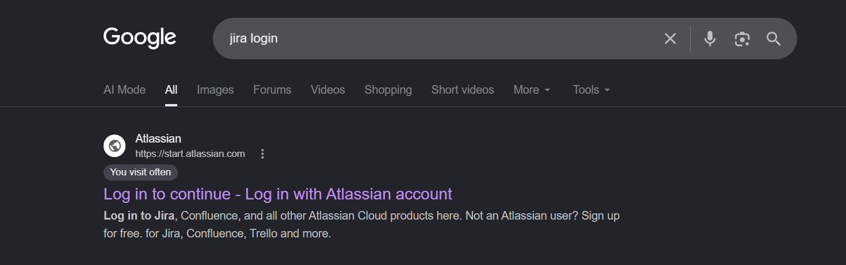
Figure 1. Opening Jira Cloud.

Step 2:

Open the Jira workspace from the left panel.

Step 3:

Click Create Space to create a new project.

Step 4:
Select Software Development as the category and choose the Kanban template. Click Next.
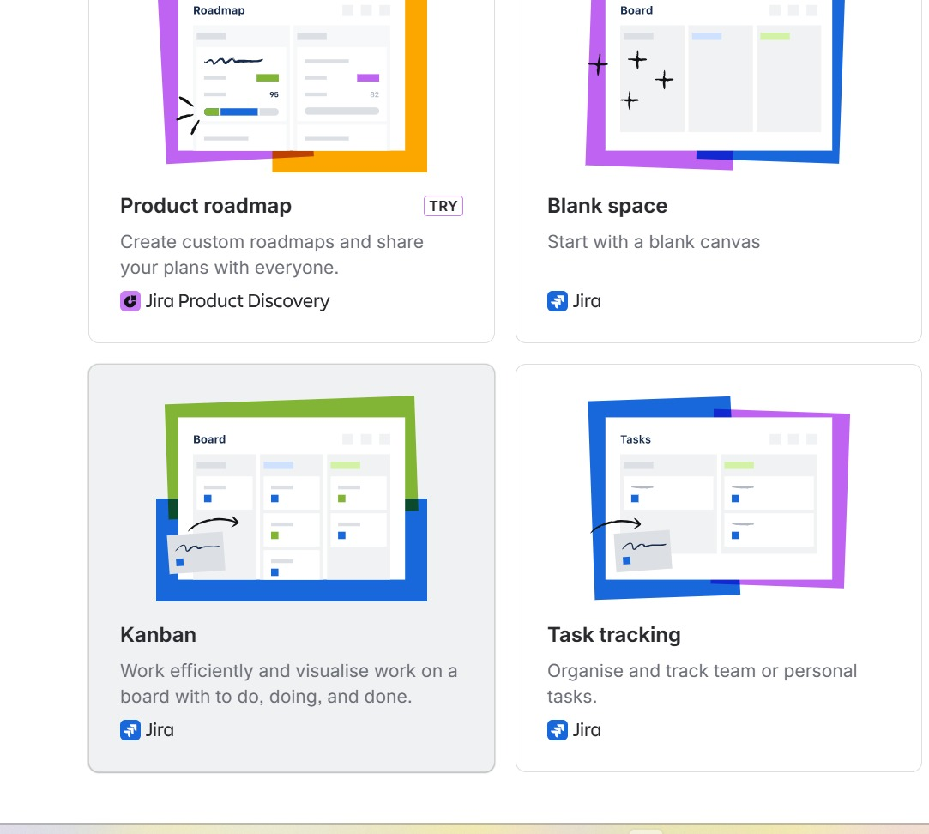
Figure 2. Selecting Kanban Template.

Step 5:

Enter the following details:
Choose Company-managed.
Enter:
- Project Name: JNM
Click Create Project.
Click Next.
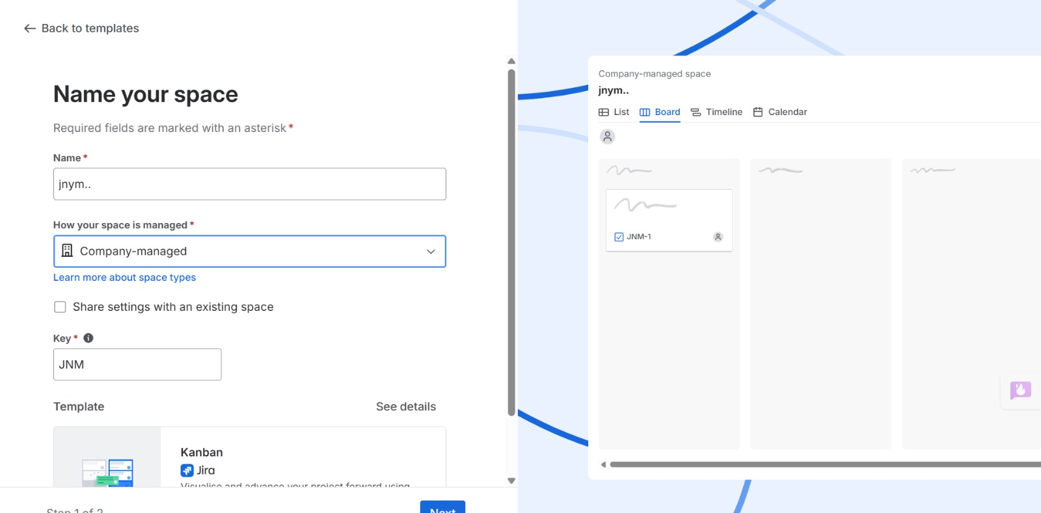
Figure 3. Entering Project Details.

Step 6: The Kanban Board is created with the workflow columns:
- Backlog
- Selected for Development
- In Progress
- Done
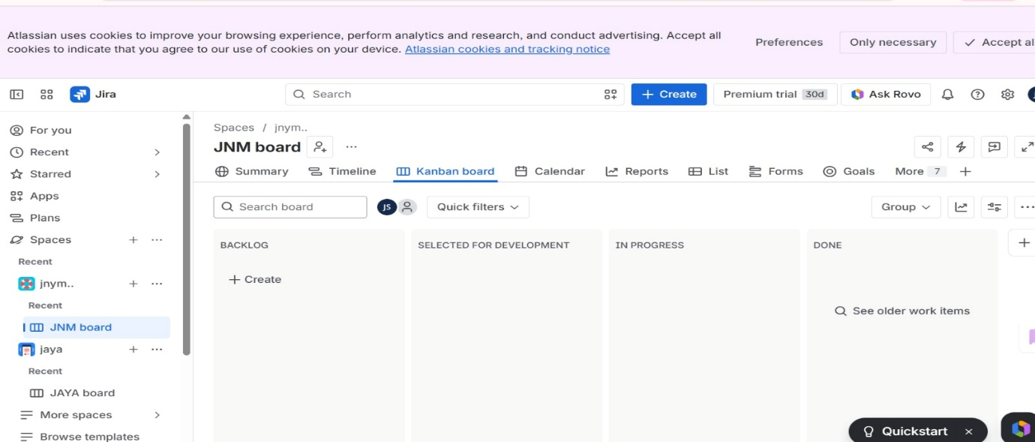
Figure 4. Created Kanban Board.

Step 7:

Add 5 Tasks
Click Create.

Task 1, Task 2, Task 3, Task 4, Task 5
Click Create.

Step 8:

View the Board
All five tasks will appear under To Do.

Step 9:

Move the Tasks
Drag and drop the cards.
Move:
To Do
To In Progress
To Done
According to the status of each tasks.
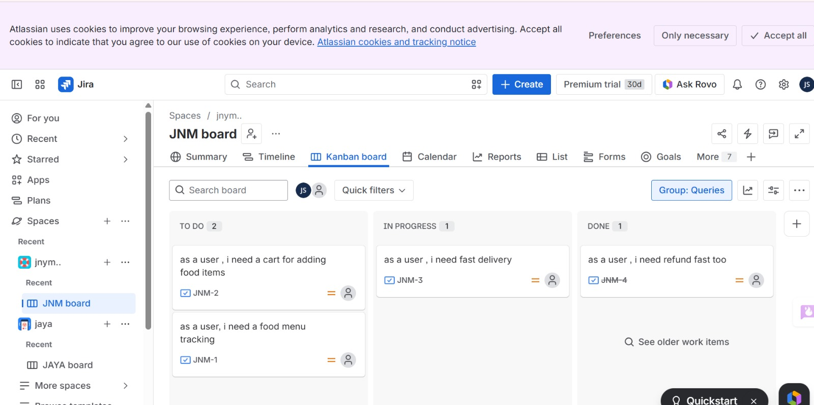
Figure 5. Updating Task Status.

Result
The Kanban Board was successfully created in Jira Software. Sample tasks were added and moved through different workflow stages, demonstrating task tracking and project management using Kanban.

